1. Introduction

Whether campus based education or distance learning, universities and educational institutions all over the world are using learning management systems (LMS) to support and improve learning within their respective institutions. Every organization’s e-learning platform depends on a chosen pedagogical approach; it is widely acknowledged that good learning design specifications and sharable learning objects are crucial for widespread and efficient learning experience. These play a significant role in introducing contents and concepts to learners, and offer great potentials for teachers to create learning designs and effective learning objects [1, 2].

Learning objects are resources, usually digital and web-based, that can be used and re-used to support learning. They offer a new conceptualization of the learning process, instead of the traditional classroom hours; they provide smaller, self-contained, re-usable units of learning [3]. Learning objects typically have different components that range from descriptive data to more general information. However, will-be instructional content, interactive elements and assessment tools are the core of the learning objects. Their design raise issues of portability, reusability, efficiency, maintainability, reliability, and integration into learning management systems [4, 5].
However, designing an interactive course in order to teach how to properly read and recite the Glorious Quran can be a very complicated process to start with. This would imperatively require a qualified teacher to aid in verifying the correct pronunciation and other phonetic and phonological rules. Although, there are several learning methods which are suitable for Arab and non-Arab learners, the ultimate result however remains the same for all Muslims which is to properly learn how to read and recite the Glorious Quran.
This research paper addresses the issue of studying Quranic sciences in general, and specifically how to learn to read and perform Quran recitation rules (tajwīd), by developing a prototype for standardized learning objects that can be delivered through customized learning designs integrated into dedicated LMS, or Learning Contents Management Systems (LCMS), for Quranic sciences.
2. Core Quran learning objects for tajwīd
Learning objects are a new way of thinking about learning content, these have key characteristics and contain different kinds of information integrated together in order to form a core unit that can be used for a multitude of learning content applications, and often stored in an XML file format [3]. These have the following key characteristics:
- smaller units of learning, self-containedm, i.e. each learning object can be taken independently,
- reusable as a single learning object that may be used in multiple contexts and for multiple purposes,
- can be aggregated and grouped into larger collections of content, including traditional course structure,
- tagged with meta-data, that is descriptive information allowing it to be easily found by a search engine.
The types of information that may be included in a learning object and its meta-data can be described comprehensively but not exclusively as follows [4]:
- General course or unit descriptive data including: course identifiers, subject area (reading, reciting, audio, video, etc.), descriptive text, descriptive keywords, glossary of terms, and educational level.
- Development cycle including: version, status, rights, cost, copyrights, and restrictions on use.
- Instructional content including: text, web pages, images, audio, video, links.
- Quizzes and assessments including: questions, answers, home works.
- Relationships to other units and courses including: prerequisite units and courses.
For the purpose of this research project and taking into account all the fundamentals of learning objects described above, the basic and natural component of a learning object to be considered for Quran is the ayah, which is the core unit that can hold a basic meaning to a full story. This is a unique feature of the Glorious Quran that makes it an ideal unit to be used as a learning object and should be developed or studied in relation to the rest of the other ayahs in Quran. The meaning, function, and usage of ayahs, within learning objects, can be further defined and expanded by scholars depending on the Quranic science being used and various meanings that ayahs can hold.
Tajwīd (تجويد) is one of the Islamic rules based sciences that are related to the Ayah Quran. It became mandatory for rules to be put down that would preserve the recitation of the Quran from mistakes, and guarantee the reader of the Quran integrity of pronunciation.
Linguistically, tajwīd means to make well, make better, or improve, that is proper pronunciation during recitation of Quran, as well as recitation at a moderate speed. It is a set of rules which govern how the Quran should be read. There are several principles in the science of tajwīd which should be understood that are basically:
- knowledge of the places of articulation of sounds (makhārij al-hurūf),
- knowledge of the characteristics of sounds (sifāt al-hurūf),
- knowledge of what rules change in the sounds due to their order,
- exercising the tongue through repetition.

Although the details of the above principles may vary slightly from one school to another, these should basically be the core of any tajwīd learning object that can be amended within its context by different schools.
Figure 1 illustrates the basic Quran learning object for tajwīd based on a single core unit which is the ayah. Although this tajwīd learning object can hold a large number of details and can be further developed, the main features that have been considered at this stage in this project are:
- visual features: display sūrah, display a ayah, zoom ayah in/out, display rulings (ahkām) in ayah, display lessons, display rulings examples.
- Audio features: reader selection, selection of part of a sūrah audio, synchronize the display of visual, audio, and rulings in an ayah, record tajwīd test, evaluate tajwīd test, and other test options.
- Related Quran learning objects: tafsīr, fiqh, hadīth, i^{c}jāz-^{c}ilmī (scientific facts) in the Quran, Islamic history, and further Quranic sciences can be added as required and defined by scholars.
- Learning object maintenance features: thematic search engine, help, translation, convert to standard format (e.g. SCORM), and options.
- Reusability: these learning objects will be the basic components that can be reused to amend or build more learning features, which make them flexible and expendable.
Besides the highlighted features of tajwīd learning objects, which are unique to the Glorious Quran, there are several other tools that are being defined and developed within this project such as: identifying each ayah in terms of text or image, identifying each ayah reading in terms of audio, identifying all details of rules of tajwīd within a ayah in terms of text/image display and audio, synchronization and indexing mechanisms for visual display of a ayahs, audio reading, and display of rulings for efficient self learning of tajwīd.
Quran Learning Object for Tajwīd
(based on a single ayah)
Ahkam (rulings):
Display rulings lessons
Display rulings examples
Display:
Display sūrah
Display a ayah
Zoom ayah in/out
Maintenance:
Thematic search engine
Help
Translation
Conversions to standard formats
Options
Related Topics:
Tafsir
Fiqh
Hadīth
I^{c}jāz-^{c}ilmī
Islamic history
Translation(s)
Other Sciences
Audio-Video Synchronization:
Reader selection
Select part of a sūrah audio
Display of visual, audio, and
rulings of a ayah

Tajwīd test:
Record tajwīd test
Evaluate tajwīd test
Other test options
Visual Features
Audio Features

Figure 1: Basic Quran object for tajwīd based on an ayah as a single core unit
3. Standard for Quran learning objects
Although this paper explorers the issue of reading and reciting the Glorious Quran, by developing specific tajwīd learning objects, there is a more general and bigger aim to this research project; the development of a prototype for a standardized learning object(s) for Quranic sciences as a whole (Figure 2), which can be delivered through customized learning designs and styles, and integrated into LMS. This standard is a key element in unifying most of the efforts made worldwide in the development and implementation of IT technologies in Quranic sciences. This would build a reference model and library for all educational institutions and individuals alike, if such a unique standard is approved and authenticated by our eminent scholars.
Tafsīr Learning Objects
Hadīth
Learning Objects
I^{c}jāz-^{c}ilmī
Learning Objects
Islamic History Learning Objects
Fiqh Learning Objects
Tajwīd Learning Objects
Quranic
Sciences
Learning
Objects

Figure 2: A prototype for standardized learning objects for Quranic sciences
4. Dedicated LMS platform for Quranic sciences
Before any institution invests a great deal of time and energy into building high-quality e-learning content it needs to consider how this content can be easily loaded into LMSs.
Electronic learning (e-learning) is a type of technology supported education/learning where the medium of instruction uses a wide spectrum of computer technologies. It is defined as a planned teaching/learning experience that, is mainly internet or computer-based, to reach learners. It is used interchangeably in a wide variety of contexts and refers to the strategies used to deliver training courses as well as defined as a specific mode to attend courses or programmes of study where the students can attend face-to-face teaching for on-campus access to educational facilities, and/or they can study online. E-learning is naturally suited to distance learning and flexible learning, but can also be used in conjunction with face-to-face teaching, in which case the term Blended Learning is commonly used [1].
From the educational methodology perspective, e-learning Course or e-course is considered as an independent learning unit that encloses all the necessary self-educational learning material and tests for controlling and evaluating apprehension of the learning material. It consists of structured sets of learning modules that are fundamental building blocks of the course. It corresponds to a lesson or lecture which has thematically coherent and complete learning materials. Depending on structures of learning content modules, it can be grouped and arranged using hierarchy chapters. These learning modules are based on well-defined and related learning objects gathered to convey a specific learning theme or target. By improving or adding more features to these learning objects, built up modules and ecourses are consistently and methodically being enhanced [5].
Creating an e-course or e-learning content requires putting together a sequence of learning objects. Much effort is put into the technical re-use of electronically-based teaching materials and in particular creating or re-using Learning Objects. Such content can be serialized into a standard format such as XML and loaded into LMSs. When you consider that some e-learning courses need to include video, audio, mathematical equations, and other complex structures, the issues become very complex, especially if the LMS needs to understand, validate, and accommodate each structure, which is the case for tajwīd-learning-objects-based courses and materials.
A learning management system is usually a web-based software that facilitates access to learning content and administration. LMSs range from systems for managing, keeping and tracking course or training records, to software for delivering and distributing courses over the internet, and offering features for online collaboration.
LMSs are based on a variety of development platforms, from Java EE based architectures to Microsoft.NET, and usually employ the use of a database back-end. While most systems are commercially developed and frequently have non-free software licenses or restrict access to their source code, free and open-source models do exist [2].
Due to the special and unique nature of Quranic sciences and the various fields of studies involved, learning contents of this nature should be certified and authenticated by well know scholars in order to avoid any misuse and misleading information about the Quran or any other aspects of our religion. For this reason a dedicated LMS platform, which can be an LCMS as well, has to be considered and developed for the benefit of all Muslims as well as to make sure that reliable Quran learning objects are being used worldwide for developing elearning/course contents and/or for Da^{c}wa proposes.
For the purpose of this project an open source prototype solution has been considered and is being used in order to develop a dedicated LMS for Quranic sciences and for tajwīd specifically. Dokeos LMS has been used in this case, although there are several other open source systems that can be used which provide more or less the same sort of functionality and features [7]. At this stage of the project, Figure 3 shows the LMS platform that consists of:
- LMS management tools such as: course management, learning path, testing, reporting, communication, collaboration, authoring, maintenance, and search engine.
- Central repository for Quranic sciences learning objects that can include tajwīd learning objects, tafsīr learning objects, fiqh learning objects, i^{c}jāz-^{c}ilmī learning objects, hadīth learning objects, and further related learning objects can be added as required.
- Development of dedicated tools for customization, building, and delivery of the various related activities and Quranic sciences learning objects, which makes this learning system a unique platform as such.
This dedicated Quran LMS can be further extended in terms of management tools that are required for building appropriate learning activities based on the large amount of Quranic sciences learning objects that can be made available through the central repository. Furthermore, the central repository for Quranic sciences learning objects should be well-defined, designed, and organized by our eminent scholars. In addition, the learning contents of such a central repository should be authenticated by official institutions in order to preserve the integrity of the information and provide reliable source of information worldwide as a reference library.

Quran
LMS
Platform
I^{c}jāz-^{c}ilmī Learning Objects
Tafsīr Learning Objects
Tajwīd Learning Objects
Fiqh
Learning Objects
Management
Learning
contents
Authoring
Assessment

Hadīth Learning Objects
Communication
Collaboratio
Reporting
Maintenance
Search engine
LMS Management tools
Central Repository for Quran Sciences Learning Objects

Figure 3: Dedicated Quran LMS platform

Figure 3: Dedicated Quran LMS platform
5. Implementation
This first phase of the project is primarily a feasibility study on how Quran learning objects can be defined, developed, and applied for in the context tajwīd, based on a single core unit which is the ayah. A prototype tajwīd learning object is being proposed that can be extended and further standardized with the right parties on board such as scholars, Islamic institutions, and experienced software developers.
After the feasibility study has been achieved, Courselab has been found to be the most suitable e-learning authoring tool that offers programming free environment for creating high quality interactive e-learning content which can be published on the internet. Courselab allows for an efficient build up of various components such as: meta-data info, contents, audio, video, activities, processing, as well as it allows for JavaScipt codes to be developed and embedded within Courselab that would be essentially needed for the development of unique features for Quran learning objects that are not readily available in such packages [6].
Furthermore, Courselab enables building complex multi-object interactions with interfaces based on an Open Object Model to easily extend and enhance existing libraries of objects and templates including those created by the user. The latter features makes such a package a very attractive option for expanding applications as well as Courselab itself since it is an open source software where the codes are available to users for further development.
Initial results are illustrated in the figure below that shows a typical user interface for tajwīd application where the learner can access a multitude of information, functions and activities, which are all defined and implemented within a tajwīd learning object based on a single ayah. Some functions are hidden in the graphical user interface (GUI) to make it user-friendly, and can be accessed as appropriate to the user if needed.
Tajwīd Learning objects are being built as a prototype with the following characteristics that some of them are visible in the Figure 4:
- display and zoom of ayahs with different Arabic scripting,
- display/Highlight of rulings within the text,
- various readers/reciters,
- details and examples of rulings of the Quran,
- tajwīd test or quiz (this feature will consist of several types of tests including audio test that needs to be defined),
- various tools such as help, translation, options, and search,
- links to other Quranic sciences learning objects related to the specific ayah being displayed.
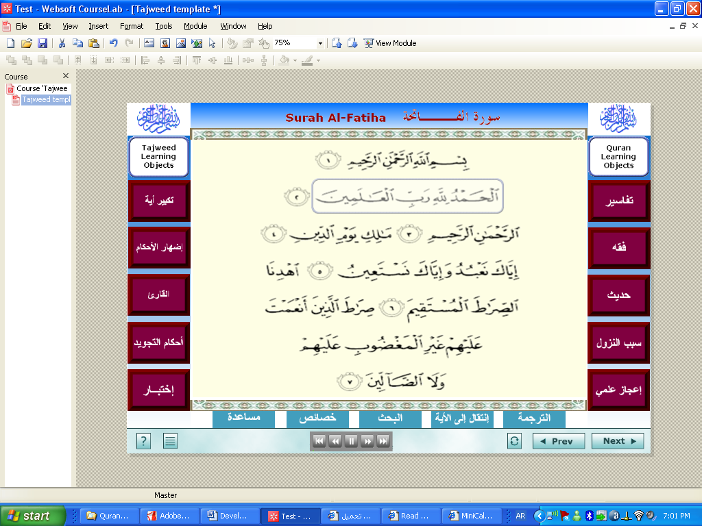
إظهار الأحكام

Figure 4: A prototype build of tajwīd learning object
However, there is a number of processing components that have been or are being added to the learning object for full and comprehensive functionality. These can be summarized as follows:
- Identifying each ayah in terms of text or image for display,
- identifying rulings of tajwīd details in text and image for display,
- identifying rulings of tajwīd details in audio,
- mechanisms of indexing ayahs, audio, and rulings,
- synchronizing visual display of text, audio, and rulings of ayahs,
- various user’s audio tests (this to be developed in the next phase of the project due to its complex nature),
- thematic search engine that will deeply and more efficiently help in the study of Quranic sciences,
- development of the relationship with the rest of Quran learning objects,
- finally, the development of deployment methodologies for LMS, and how teachers and learners can efficiently use Quran learning objects to build up dedicated e-learning contents or ecourses.
Obviously, Courselab needs to be translated into Arabic, as well as the development of Arabic support with further Courselab components, in due time. This is in order to add unique tools that are needed to build up comprehensive tajwīd learning objects as well as a more general Quran learning objects. This is in addition to methods for deploying Quran learning objects and e-learning contents that can be embedded into Learning Management Systems, and the interaction between learning objects would enable more efficient management of the overall learning process.
6. Conclusion
A prototype tajwīd learning object has been presented that can be extended and further standardized with the right parties on board such as scholars, Islamic institutions, and experienced software developers. This research project is at its infancy and requires more human and financial resources in order to reach its aim that is to develop standardized learning objects for Quranic sciences based on educational standards.
As well as the development of Quran learning objects in all fields of Quranic sciences, a central repository is being proposed that allows educators to create and share custom curriculum based on Quran learning objects that are agreed upon and classified by our eminent scholars, and then integrated within customized LMS dedicated to Quranic sciences.
Further development of Courselab, or the customised version of it, would be the most comprehensive package for optimising and customizing the use of Quran learning objects and related learning content, and incorporating these components in LMSs for more efficient management of the overall learning process and specially to unify all the efforts that are currently being made in this field of customizing contemporary technologies for the service of the Glorious Quran.
Acknowledgement
The author would like to thank Taibah University and the College of Computer Science and Engineering for all the support that I have been provided with. I would like to thank, as well, Dr Ali Al Mogbel and Dr Amar Arbaoui for their valuable help and collaboration.
References
- Karrer, T (2007), “Understanding eLearning 2.0”,
http://www.learningcircuits.org/2007/0707karrer.html
- Nagy, A, Bruck, P.A.; Buchholz, A.; Karssen, Z.; Zerfass, (2005), “E-Content: Technologies and Perspectives for the European Market”, Springer-Verlag, Berlin.
- Beck, Robert J. (2008), “What Are Learning Objects?”, Center for International Education, University of Wisconsin-Milwaukee.
- Learning Technology Standards Committee (2002), “Draft Standard for Learning Object Metadata. IEEE Standard 1484.12.1”, Institute of Electrical and Electronics Engineers (IEEE), New York.
- Shaw, Michael (2003), “ (Contextual and Mutated) Learning Objects in the Context of Design, Learning and (Re)Use”, Teaching and Learning with Technology.
http://www.abouttajweed.com/, as cited by the author on 20th October 2008.
- “CourseLab 2.3 User Manual” (2007), http://www.courselab.com/, as cited by the author on 5th June 2008.
- http://www.dokeos.com/, as cited by the author on 25th February 2009.

